11 th Annual Sweetwater Jaycee Roosters
Fall Motorcycle Rally & Cook-Off & Swap Meet
September 25, 26 (cook-off) & 27th, 2020 (CMA Church service)
ALL BIKERS and COOKERS WELCOME. There will be Vendors available.
Cook-Off Campsites Bathrooms Showers
Electricity Motels (in town) Bike Games Bike Shows
$1000 Poker Run Raffles 50/50 Drawing Swap Meet
(No Pets without Prior Approval)
Live Music Sunday Services Cook-Off
Brisket, Pork Ribs (rack), Chicken, Chili
$5.00 Bulls-eye Beans
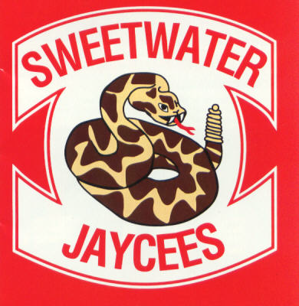70% Payback
Team Calcutta – 50% Payback
Cook - $80.00, Bike Registration – $25.00

Electricity – $10.00/day~RESERVATION ONLY
Free Patch & Pin for Pre-Paid Biker & Cooker
ROOSTERS
Directions: Take FM 1856 exit off I-20 (1 mile E of Sweetwater) south on FM 1856 approximately 5 miles to the Y, Take left Fork (FM 2035) about ¼ mile, turn right into park!

Registration Form
Send Registration to: JAYCEE ROOSTERS, BOX 851, Sweetwater, TX 79556
Name: Cook Team Name:
Address:
Phone:

For More Info Contact: David Sager (325-721-2293)

We agree not to hold the Sweetwater Jaycee Roosters or the City of Sweetwater liable or responsible for any accident, injury, or damage to our personal property while attending the Bike Rally/Cook-Off.
Signature: Date:

